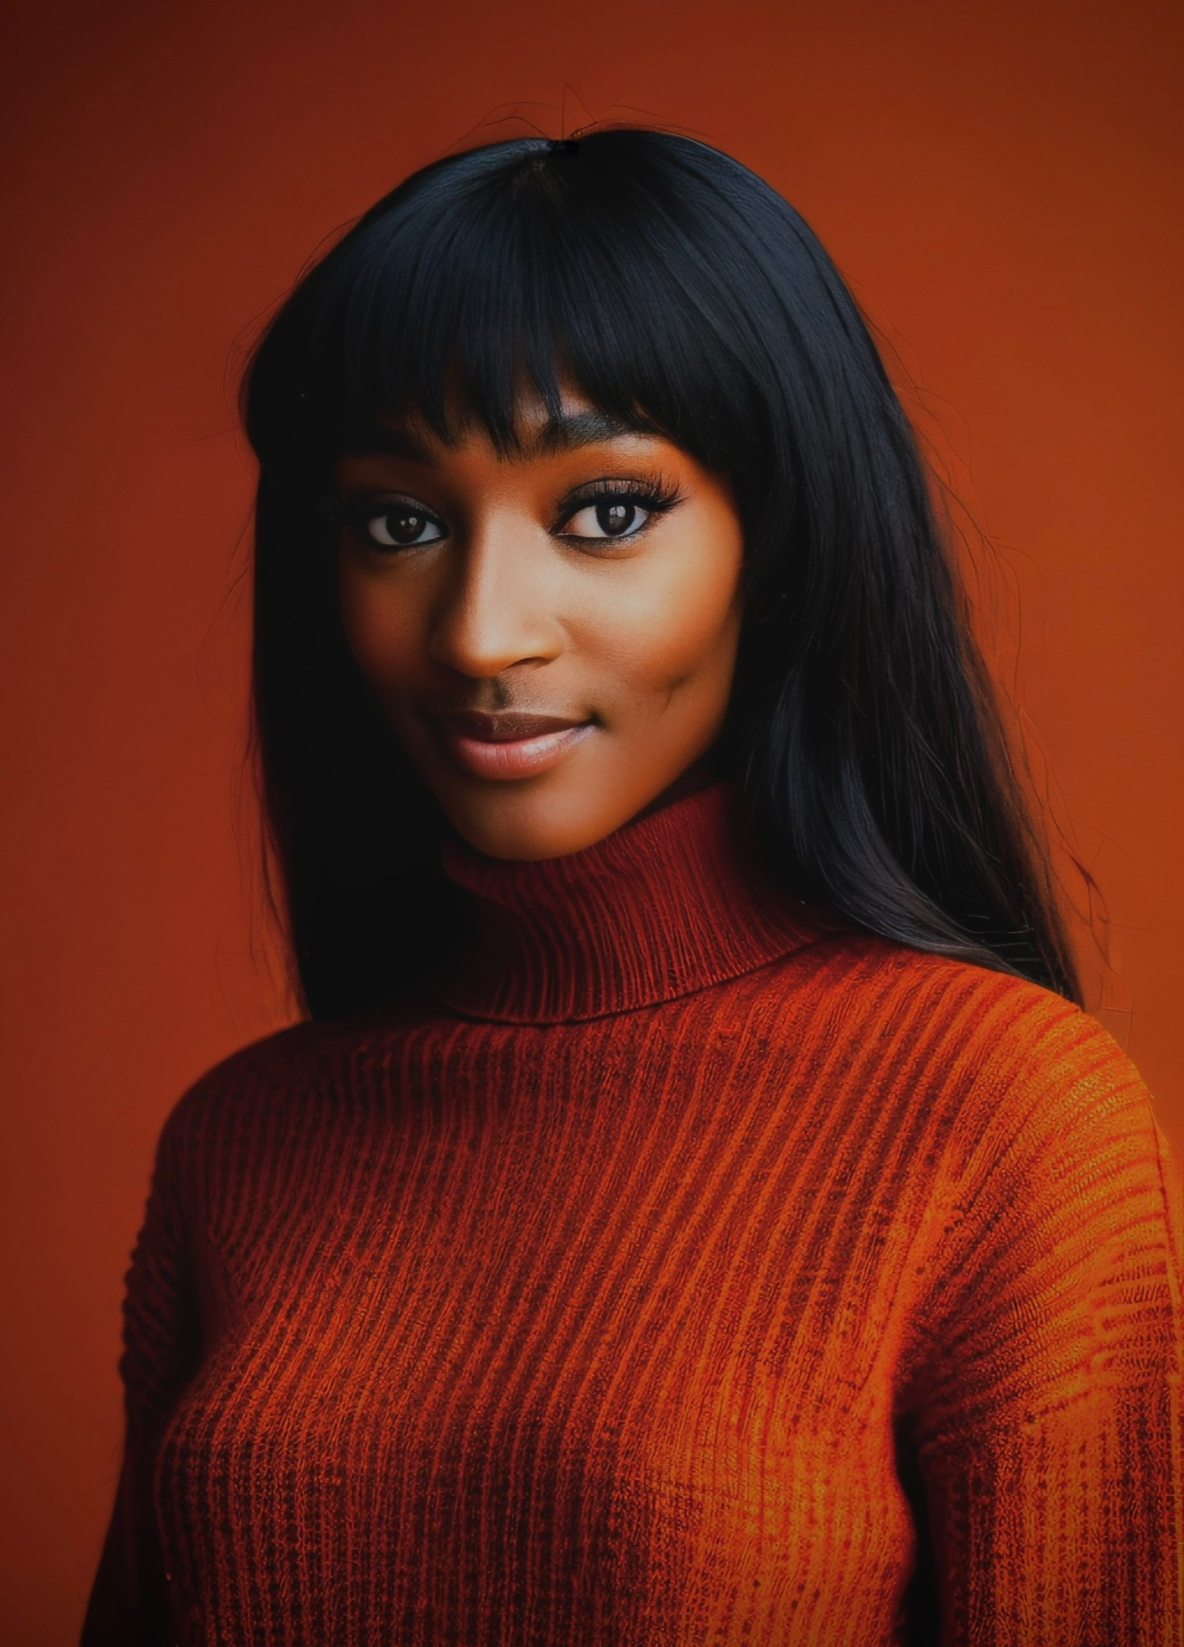
Nia Young

(Non-Union)

321-245-3496
Niaelise10@gmail.com
www.niayoung.com

Height: 5’ 6” (168 cm)
Weight: 118 lbs (53.5 kg)
Eye Color: Brown
Hair Color: Brown
_______________________________________________________________________________________________________________

THEATER

The Last Days of Judas Iscariot Saint Monica, Simon the Zealot, Soldier 3 Atlantic Stage 2/ dir. Duran Lucio
The Wolves #2 Atlantic Stage 2/ dir. Seonjae Kim
Vigil Noelle Atlantic Theatre School/ dir. Claire Smith
Polaroid Stories Eurydice Alchemical Studios/ dir. Alec Pacheco
Do Not Go Gentle Joanna director. Jessie Cohen
You Can’t Take It With You Ensemble director. Jessie Cohen
Diary of Anne Frank Miep Gies director. Jessie Cohen
_______________________________________________________________________________________________________________

MUSICAL THEATRE

Aida Ensemble Timber Creek/ dir. Ryan Skiles
Tuck Everlasting Spirit of The Wood, Carnie Timber Creek/ dir. Ryan Skiles
The Drowsy Chaperone Trix the Aviatrix Timber Creek/ dir. Ryan Skiles
Hairspray Dynamite Dancer, Ensemble Timber Creek/ dir. Ryan Skiles
The Addams Family Ensemble Timber Creek/ dir. Ryan Skiles
Beauty and the Beast Wardrobe Timber Creek/ dir. Ryan Skiles
_______________________________________________________________________________________________________________

TRAINING

Atlantic Acting School: Practical Aesthetics Full-Time Conservatory, Class of 2023
Script Analysis: Tom Castello, Paris Ellsworth, Anya Safir
Voice/Speech: Francine Zerfas, Charley Layton
Film: Todd Thaler, Alana Barrett-Adkins, Andy Schneeflock, Rick Coke-Thomas
Voice Acting: Steve Tardio
Suzuki ViewPoints/ Alexander Technique: Kellien Maurer, Donnie Mather, Diann Sichel
Atlantic Acting School: Practical Aesthetics 2018 Summer Intensive
Voice: Francine Zerfas
Avalon Dance Company (12 Years of Training):
Modern, Ballet, Jazz, Tap, Lyrical, Contemporary, Hip-Hop, Musical Theatre ______________________________________________________________________________________________________________
SPECIAL SKILLS

Singing (Voice: Soprano1- Alto 2), Dialect (Southern American, British, Irish, Creole: New Orleans), Choreographer, Violinist, Pianist, Hula-Hooping, Jump Rope, Driving, Cyclist, Set Design, Hair/Make-up Artist, Poet, Improv

